Disturbance and Succession
Types of disturbance
Ecological disturbance

Anthropogenic disturbance

Succession

Dynamic equilibrium

Seral stages

Types of Succession

Primary

Pioneer Stage

Intermediate Stage

Climax Stage

Secondary

Successional Trends
Pioneer Intermediate Climax
BIOMASS

GROWTH

COMPETITION

DIVERSITY

Successional Models
Relay Floristics

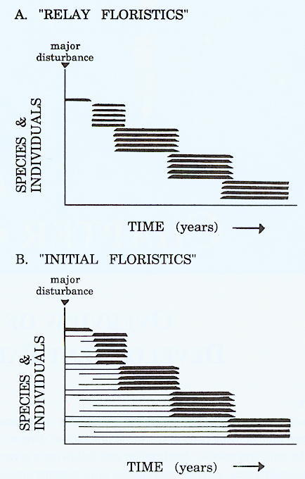
Initial Floristics

