Rarity, Dominance, and Invasion
Dominance

Rarity and Commonness

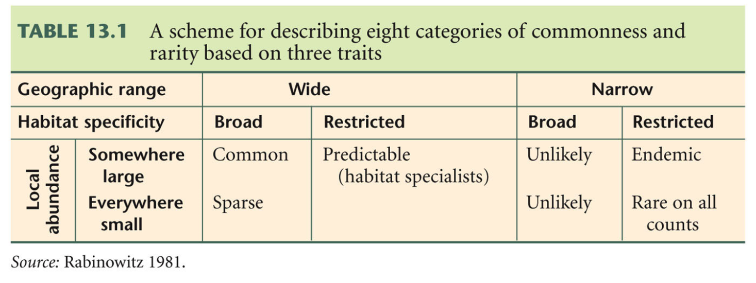

Niche

Fundamental Niche

Realized Niche

Invasive Species

Exotic Species

How invasive species spread

The tens rule of invasion

Invasion mechanisms

Enemy Release Hypothesis

