Landscape Ecology
Landscape Ecology

Patch Aggregation Patterns
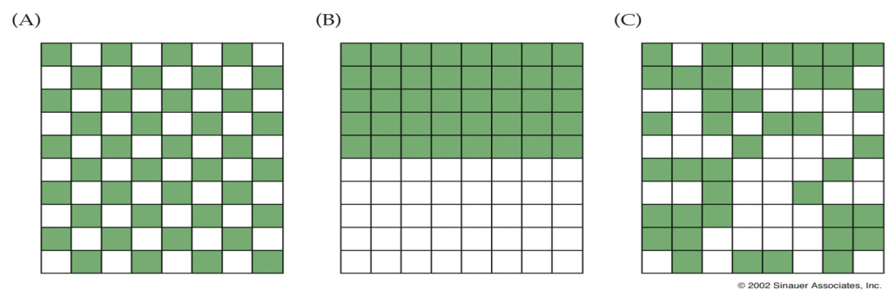

Benefits of Metapopulations

Core Satellite Model

Island Biogeography

Species Persistence

Gotelli Model

Rescue Effect

Stepping Stone Migration

Island Model

Extinction Reasons
Genetic stochasticity

Demographic stochasticity

Environmental stochasticty

Catastrophe

Destruction of refugia

