Growth and Reproduction
Quiz Today Over Population Dynamic and Evolution Lectures!
Modular Growth

Meristems

Shoots- Nodes and Internodes

Apical

Axillary

Intercalary

Vascular Cambium

Cork Cambium

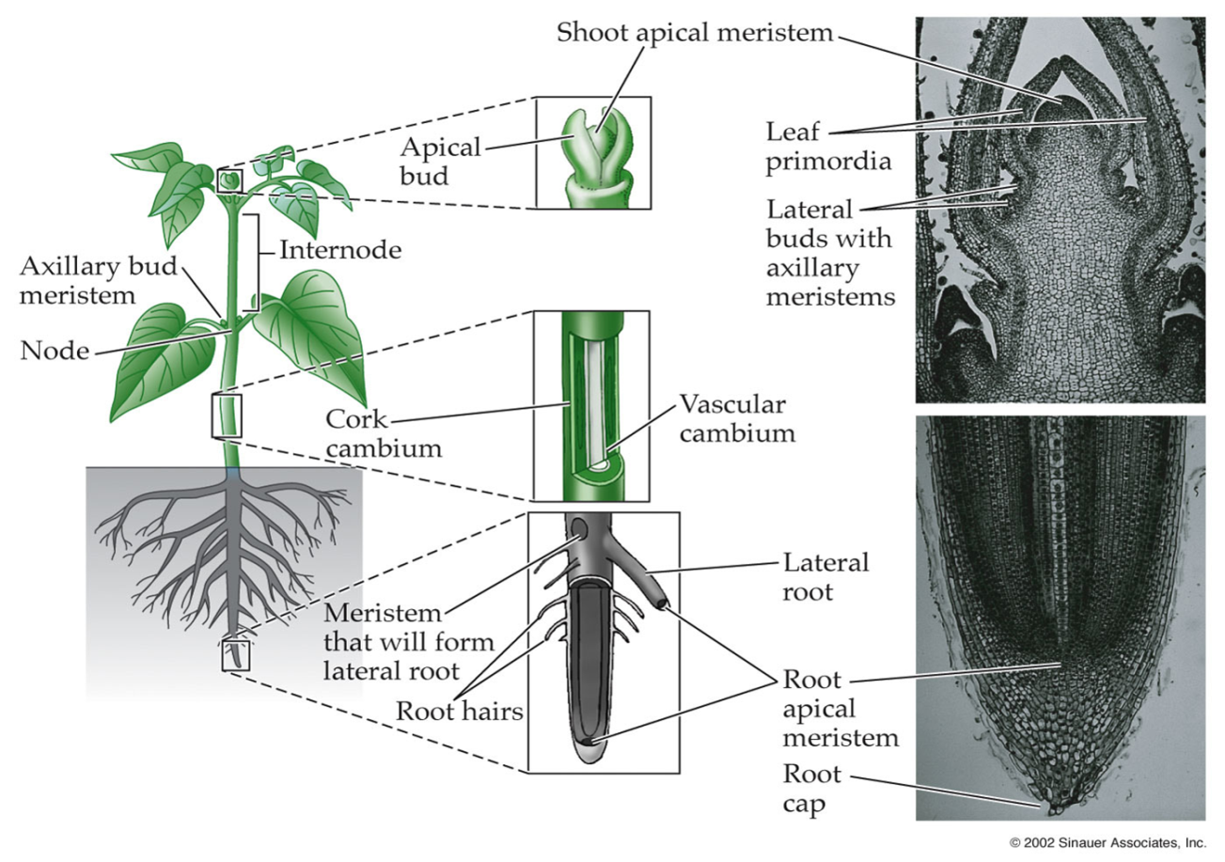
Apoximis

Agamospermy

Vegetative Reproduction

Types of Vegetative Reproduction
Stolons and Runners

Rhizomes

Patterns of spreading

Tubers and Storage Roots

Bulbs

Corms

Leaves, Adventitious Buds, Roots, and Stems

Fragmentation

Advantages of Vegetative Reproduction

Sexual Reproduction

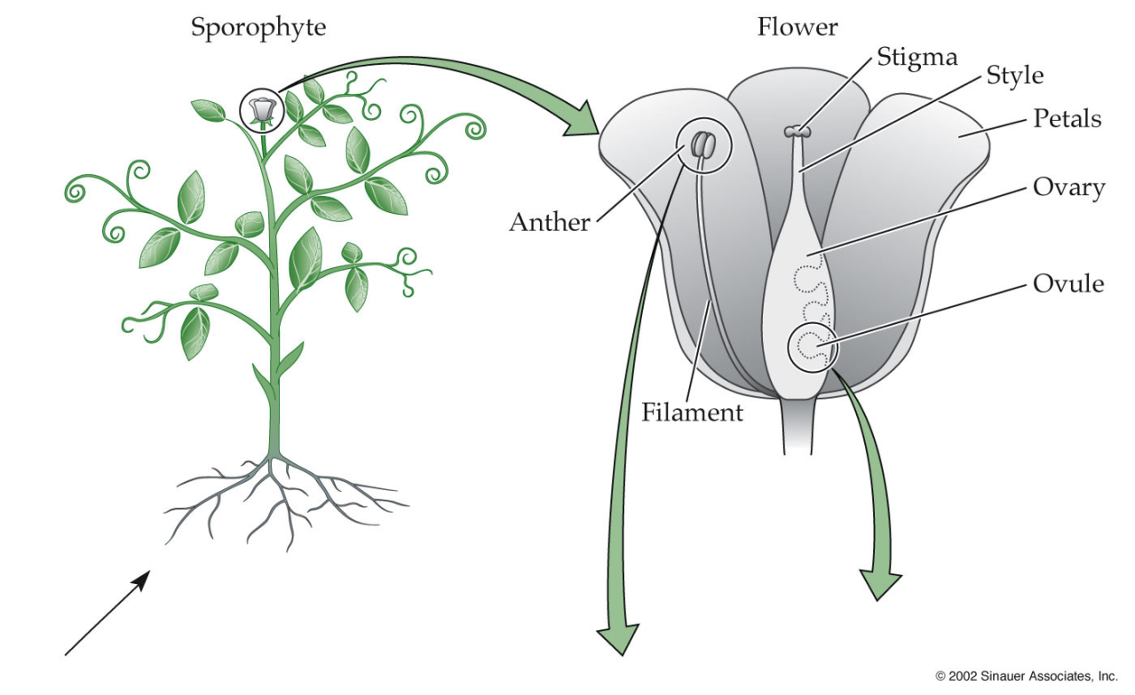
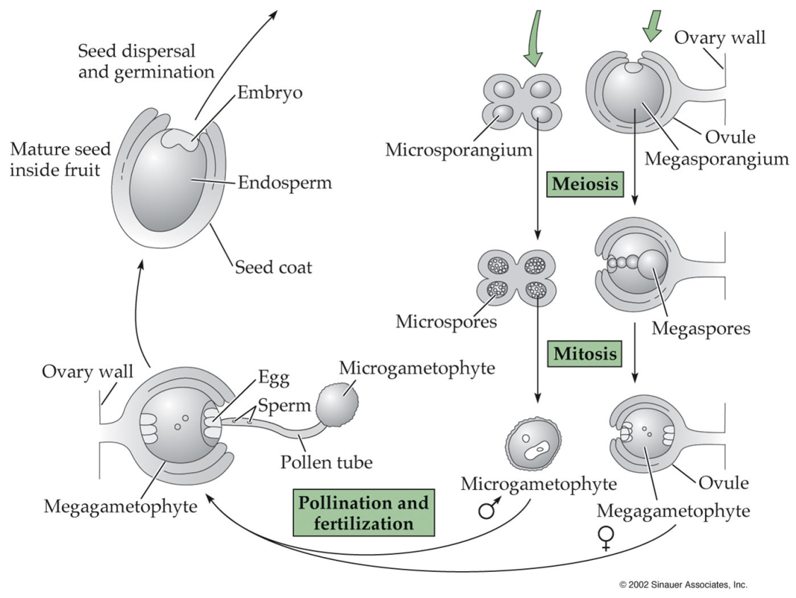
Pollination Syndromes

Pollination Prediction Indicators

Generalists vs Specialists

Advantages of Sexual Reproduction

Disadvantages of Sexual Reproduction

Heterostylous Breeding Systems

