Plant Life Histories
Trade-offs

Optimal Seed Size

Life History

Components of Fitness
Maturity

Parity

Fecundity

Aging

Extremes of Life History
Semelparity

Iteroparity

Life History Strategies
Annual

Biennial

Perennial

Semelparous

Fast vs. Slow Development

Life History Asssumptions

Maximal vs. Optimal Fecundity

r vs. K Selection
K-Selection and Traits

r-Selection and Traits

Grime Selection Scheme
Stress Tolerators

Ruderals

Competitors

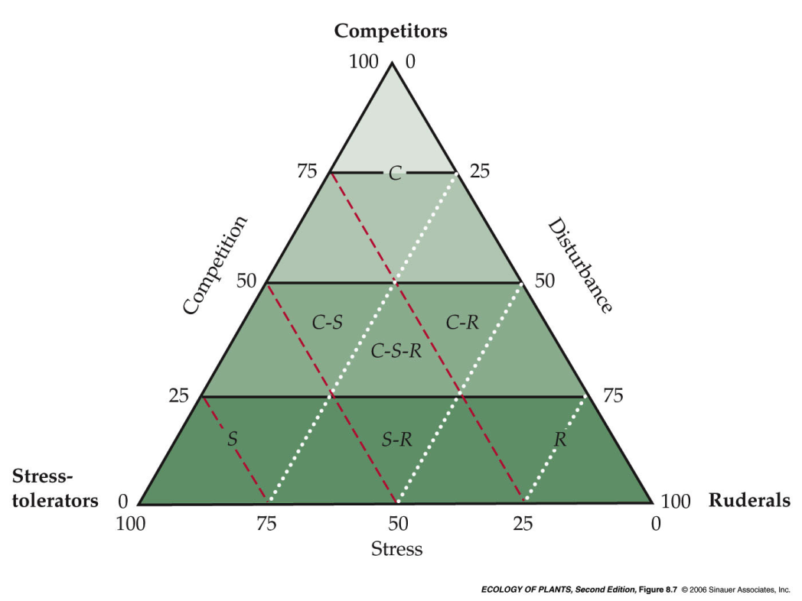

r-K Selection vs. r-c-s Selection

Masting

