Population Growth and Decline
(This is meant to be a note taking guide, you may want to adjust spacing sizes)
Population vs. Community vs. Individual

Genet

Ramet

Sources of Mortality
Density Dependent

Density Independent

Simplified Population Dynamics

Ages vs. Stages

Life Tables

Horizontal

Vertical

r vs. λ
Leslie Matrices (describing population change)

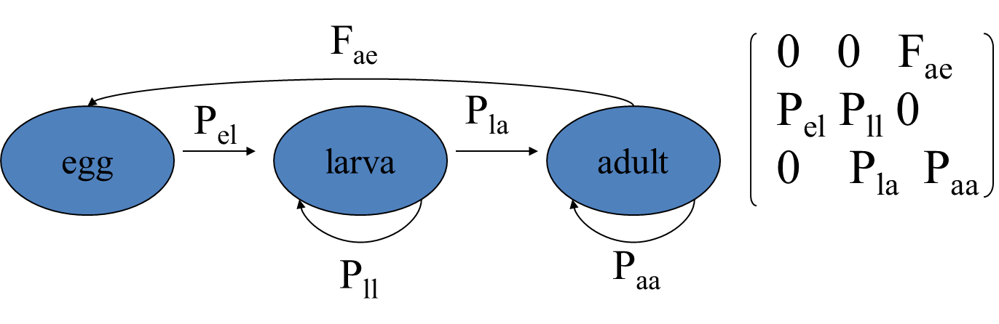
Sensitivities

Elasticities

Shortcomings

Net Reproductive Rate

Stochasticity

Environmental

Demographic

